1. **Get All Users**

This API is used for retrieving all activities from the database.

* **URL**

/activity/activities

* **Method:**

GET

* **URL Params**

Not required

* **Data Params**

Not required

* **Success Response:**

Example:

* **Code:** 200

**Content:** [{"id":1,"userId":213,"carId":22,"isRental":0,"isReservation":1},{"id":2,"userId":555,"carId":45,"isRental":1,"isReservation":0},{"id":3,"userId":456,"carId":54,"isRental":1,"isReservation":0},{"id":4,"userId":213,"carId":22,"isRental":null,"isReservation":null},{"id":5,"userId":7,"carId":4,"isRental":1,"isReservation":0},{"id":6,"userId":7,"carId":4,"isRental":1,"isReservation":0},{"id":7,"userId":7,"carId":4,"isRental":1,"isReservation":0},{"id":8,"userId":7,"carId":4,"isRental":1,"isReservation":0},{"id":9,"userId":7,"carId":4,"isRental":1,"isReservation":0},{"id":10,"userId":7,"carId":4,"isRental":1,"isReservation":0},{"id":11,"userId":7,"carId":4,"isRental":1,"isReservation":0},{"id":12,"userId":7,"carId":4,"isRental":1,"isReservation":0},{"id":13,"userId":7,"carId":4,"isRental":1,"isReservation":0},{"id":14,"userId":7,"carId":4,"isRental":1,"isReservation":0},{"id":15,"userId":7,"carId":4,"isRental":1,"isReservation":0},{"id":16,"userId":7,"carId":4,"isRental":1,"isReservation":0},{"id":17,"userId":7,"carId":4,"isRental":1,"isReservation":0},{"id":18,"userId":7,"carId":4,"isRental":1,"isReservation":0},{"id":19,"userId":7,"carId":4,"isRental":1,"isReservation":0}]

* **Error Response:**

Will be added in future:

* + **Code:** 401 UNAUTHORIZED   
    **Content:** { error : "Log in" }
* **Sample Call:**

$.ajax({

url: "/activity/activities",

dataType: "json",

type : "GET",

success : function(r) {

console.log(r);

}

});

* **Notes:**

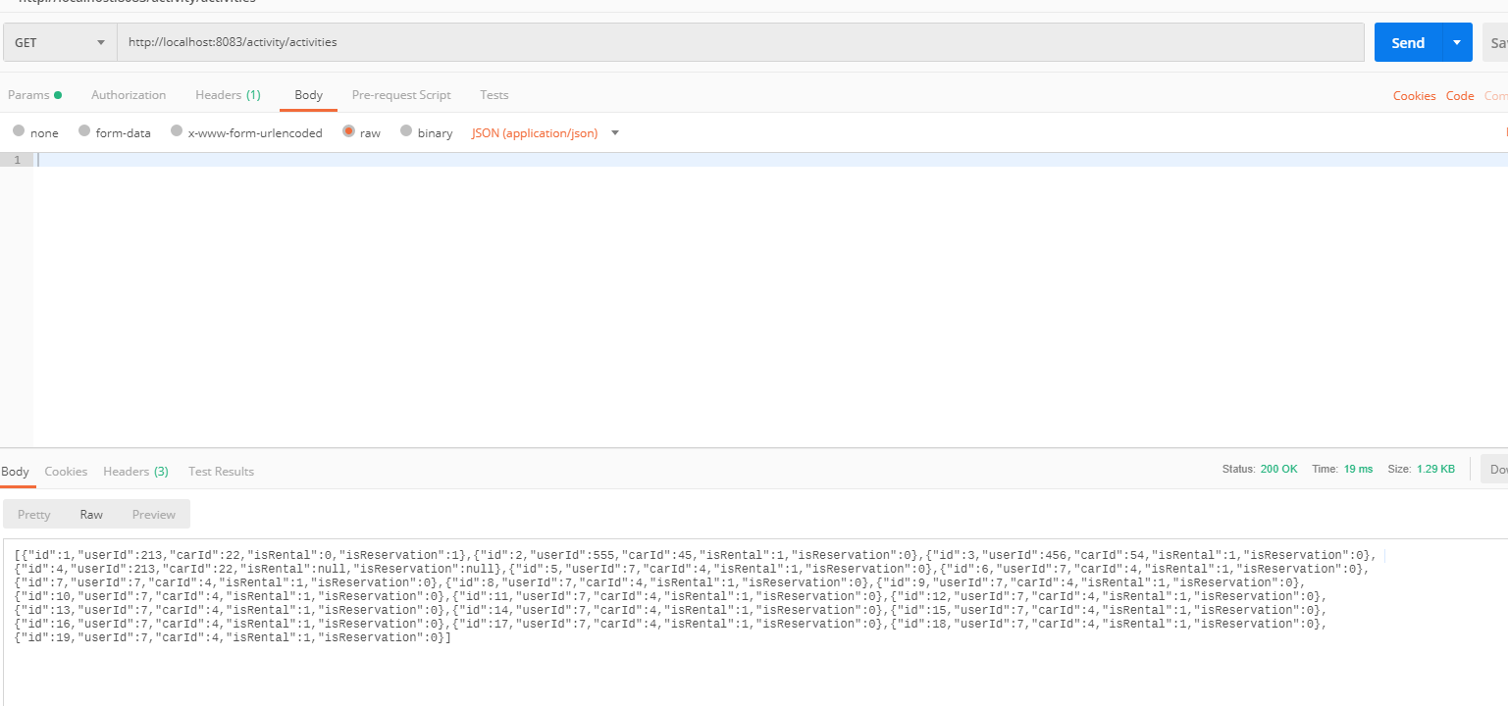

Image 1: Screenshot for GetAllActivities

1. **Get Activity By ID**

Retrieve the user with specific ID

* **URL**

activity/activities/:id

* **Method:**

GET

* **URL Params**

**Required:**

id=[Long]

* **Data Params**

Not required

* **Success Response:**
* **Code:** 200   
  **Content:** {"id":1,"userId":213,"carId":22,"isRental":0,"isReservation":1}
* **Error Response:**

Will be added in future

* + **Code:** 401 UNAUTHORIZED   
    **Content:** {"timestamp":"2019-04-18T08:30:53.753+0000","status":500,"error":"Internal Server Error","message":"User activity with this ID85 was NOT found! must not be null.","path":"/activity/activities/85"}
* **Sample Call:**

$.ajax({

url: "activity/activities/{id}",

dataType: "json",

type : "GET",

success : function(r) {

console.log(r);

}

});

* **Notes:**

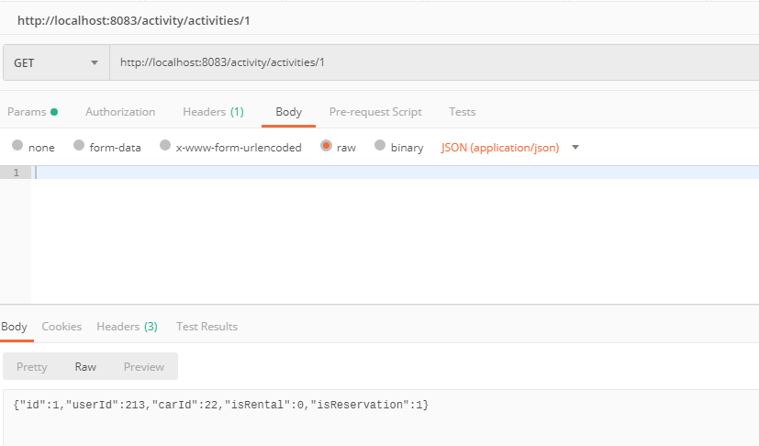

Image 2: Screenshot for GetActivityById

1. **Add New Activity**

Create new user activity

* **URL**

activities/add

* **Method:**

POST

* **URL Params**

id=[Long]

* **Data Params**

Not required

* **Success Response:**
* **Code:** 200   
  **Content:** {

{"id":20,"userId":213,"carId":22,"isRental":0,"isReservation":1}

}

* **Sample Call:**

$.ajax({

url: "/activity/addActivity/{id}",

dataType: "json",

type : "POST",

success : function(r) {

console.log(r);

}

});

* **Notes:**

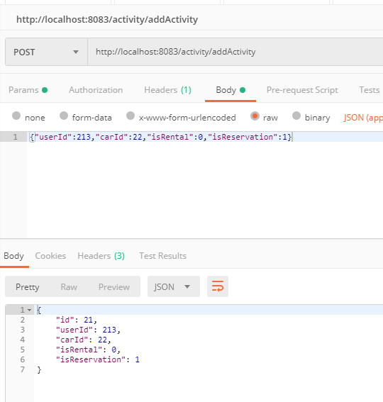

Image 3: Screenshot for AddNewActivity

1. **Delete Activity**

Delete user activity from the database

* **URL**

/activities/removeActivity/:id

* **Method:**

DELETE

* **URL Params**

id=[Long]

* **Data Params**
* **Success Response:**
  + **Code:** 200   
    **Content:** Activity with id:{id} was deleted!
* **Error Response:**

Will be added in future

* + **Status:** 404 Not Found   
    **Content:** { Unable to delete. Activity with id:{id} not found. }
* **Sample Call:**

$.ajax({

url: "/activity/removeActivity/{id}",

dataType: "json",

type : "DELETE",

success : function(r) {

console.log(r)

}

});

* **Notes:**

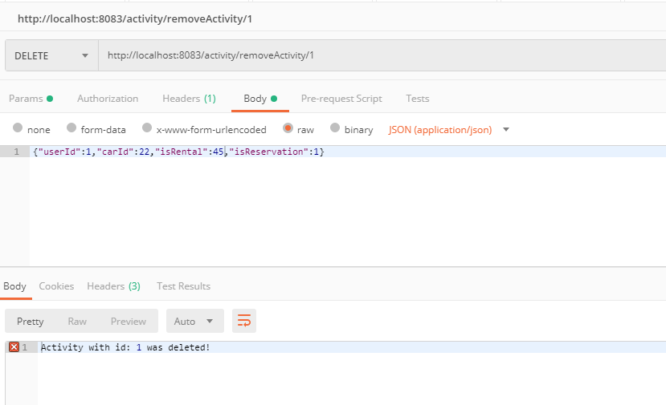 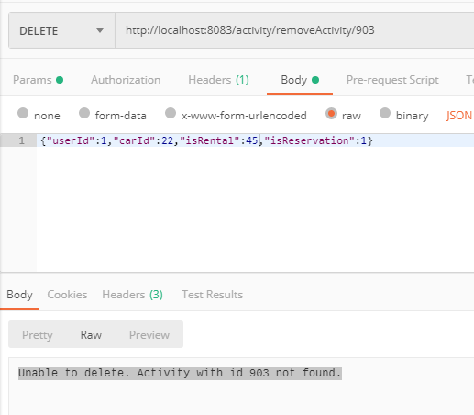

Image 4: Screenshot DeleteUserActivity

1. **Update Activity**

Update user activity from the database

* **URL**

/activities/update/:id

* **Method:**

PUT

* **URL Params**

id=[Long]

* **Data Params**
* **Success Response:**

**Code:** 200   
**Content:** {"id":2,"userId":7,"carId":56,"isRental":0,"isReservation":1}

* **Error Response:**

**Code:** 404

**Content:** Unable to update. Activity with id 1 not found.

* **Sample Call:**

$.ajax({

url: "/activity/update/{id}",

dataType: "json",

type : "PUT",

success : function(r) {

console.log(r)

}

});

* **Notes:**

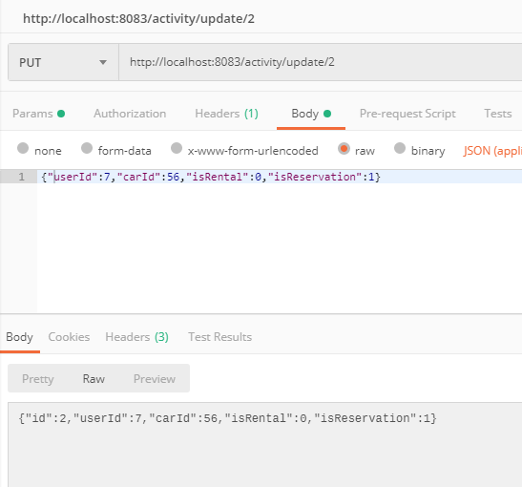 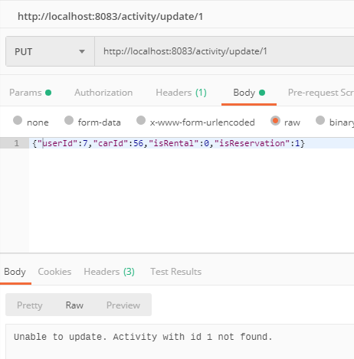

Image 4: Screenshot UpdateUserActivity